Section 1: Testing

1.1 Program 1 Part A: Representing Direct Flights

Test Data:

The following data will be used to create a SimpleDirectedWeightedGraph:

Vertices: Edges: Weights:
Edinburgh | Edinburgh ↔ Heathrow £80
Heathrow | Heathrow ↔ Dubai £130
Dubai | Heathrow ↔ Sydney £570
Kuala Lumpur | Dubai ↔ Kuala Lumpur £170
Rio de Janeiro | Dubai ↔ Edinburgh £190
New York | Kuala Lumpur ↔ Sydney £150
Frankfurt | Edinburgh ↔ Frankfurt £90
Auckland | Sydney ↔ Auckland £120
Santiago | Rio de Janeiro ↔ New York £430
| New York ↔ Santiago £320
This test data will be used as it is similar to what will be used by the final program. So if the test succeeds and the correct graph is created, the program can be described as reliable.

Expected Output:
A graph should be constructed using the given city names as vertices and the given edges.

Actual Output (Figure 1):

Figure 1: Test 1.1 Results
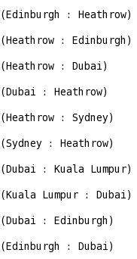
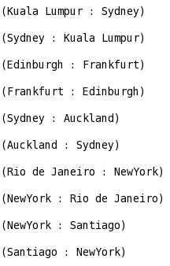

1.2 Program 1 Part B: Least Cost Connections

Test Data:
The following shortest (cheapest) paths will be calculated:

A) Edinburgh → Heathrow
B) Edinburgh → Kuala Lumpur
C) Edinburgh → Auckland
This data will be used as they provide a broad range of shortest path lengths, ranging from visiting one edge to four edges.

Expected Output:

A) Edinburgh → Heathrow should cost £80 and visit only one edge:

Edinburgh → Heathrow

B) Edinburgh → Kuala Lumpur should cost £360 and visit two edges:

Edinburgh → Dubai,
Dubai → Kuala Lumpur.

C) Edinburgh → Auckland should cost £630 and visit 4 edges:

Edinburgh → Dubai,
Dubai → Kuala Lumpur,
Kuala Lumpur → Sydney,
Sydney → Auckland.

Actual Output:
A)
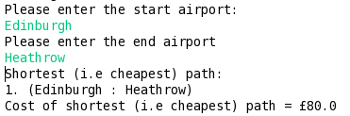

B)
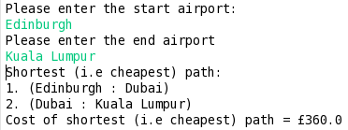

C)
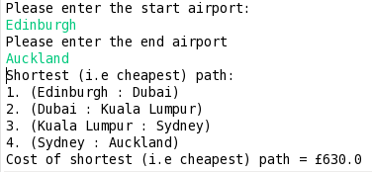

Tests 1.2 succeeded.

1.3 Program 2 Part C: Additional Flight Information
To store the additional information in the edges a new edge class was created which stores the flight price, flight number, departure time, arrival time and the duration. To test that this class functions as intended, a new edge will be created and the program will try to extract and display the data from the edge.

Test Data:
An edge going from Edinburgh to Heathrow containing the following data:

Price: 80
Flight Number: BA354
Departure Time: "21:30"
Arrival Time: "04:00"
Duration: "06:30"

Expected Output:

The program should output the given data in the correct order.

Actual Output:
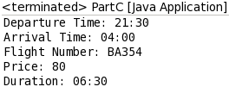

Test 1.3 succeeded

1.4 Program 2 Part D: Itinerary
The itinerary should calculate the total price for a journey and the sum of all the flight durations. It also displays information regarding each flight. The total price function has already been proven to work as well as the collecting of the additional information.

Test Data:
Display the itinerary for the journey: Edinburgh → Auckland

Output:
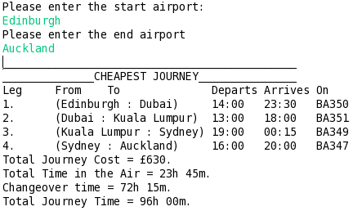

1.5 Program 2 Part E: Itinerary Duration

The function that needs to be tested here is the 24 hour time functionality. The test will need to see if multiple times in the format HH:mm can be summed to give a total time.

Test Data:
The 24 hour time functions will be used to add the following times together:

A) B) C) D)
04:30 00:00 25:00 100:00
02:20 00:15 50:00 200:00
10:00 00:20 70:00 300:00
22:10 00:25 80:00 400:00

Expected Output:
A) 39 hours and 00 minutes.
B) 01 hour and 00 minutes.
C) 225 hours and 00 minutes.
D) 1000 hours and 00 minutes.

Actual Output:
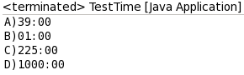

Test 1.5 succeeded

1.6 Program 3 Part F: Alternative Extensions
Extensions 1, 2, 4, and 5 were completed.

For Extension 5, a spell check function was added to the program to ensure that even when the user misspells a word the program will still find a route. It uses the spell check functions similar to the first coursework – Insertion, Omission, Substitution, Reversal.

Test Data for Part 1
The total time for the journey Edinburgh → Auckland will be calculated. It should be calculated as the sum of the flight durations and the change over times.

Output for Part 1
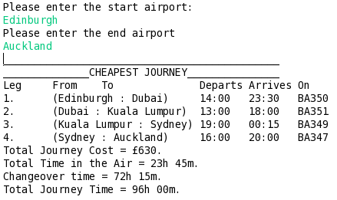

Test Data for Part 2

The program should calculate the total time of the journey even when flights fly overnight into the next day. So the total time for the journey Edinburgh → Heathrow will be calculated, as this journey departs at 21:30 hrs and arrives at 04:00 hrs the next day.

Output for Part 2
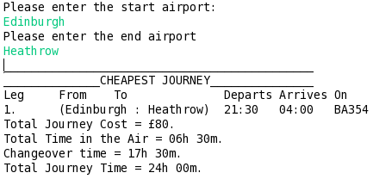

Test Data for Part 4
The program should calculate the cheapest route from Edinburgh → Auckland as well as the shortest one.

Output for Part 4
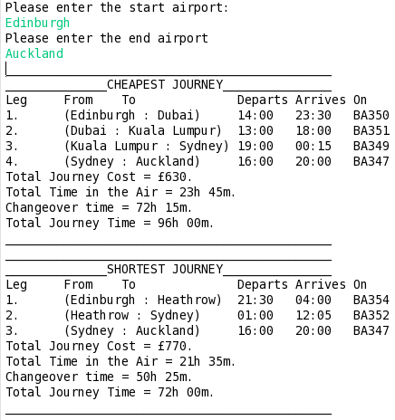

Test Data for Part 5

The program should correct the following misspelt words to Edinburgh:
Edinburhg, Edimburgh, Einburgh, Eddinburgh.

Output for Part 5
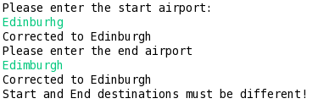
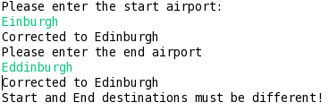
Section 2: Evaluation

Overall I feel like I handled the task well however I could have made some optimisations in certain areas. I need to get out of the habit of programming something in the easiest way for me to understand, rather than the best or most efficient way. If I had more time I would have made the interface a slightly neater and more aligned.

One part of the program that I did not get working was adjusting the flight durations according to the local time. I did not have enough time to fix this problem once it was discovered. If given more time I would have created a new vertex class and made it hold the difference in time from UTC. For example the vertex of Dubai would hold “+04:00”. Then whenever a journey passes through a vertex the adjustment would be made to the time calculations accordingly, first by identifying if there is a “+” or a “-” at the start of the string.

I also would have optimised the program in Part F so that if the shortest path itinerary is the same as the cheapest path itinerary, then the program would only display one itinerary.

